42.1: a) 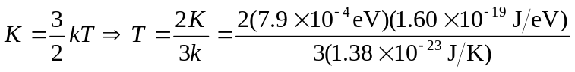

b) 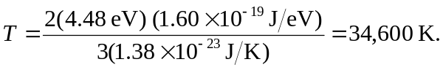
c) The thermal energy associated with room temperature (300 K) is much greater than the bond energy of 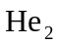 (calculated in part (a)), so the typical collision at room temperature will be more than enough to break up 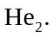 However, the thermal energy at 300 K is much less than the bond energy of 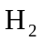, so we would expect it to remain intact at room temperature.

